Supporting document 2

Current and proposed international labelling requirements for sugars, fats and oils

Labelling Review Recommendation 12

Executive summary
As part of its technical evaluation of Recommendation 12 of Labelling Logic: Review of Food Labelling Law and Policy (2011) (Labelling Logic), Food Standards Australia New Zealand (FSANZ) has compared existing ingredient labelling requirements in the Australia New Zealand Food Standards Code (Code) for sugars, fats and oils with current legislation in the European Union (EU), United States (US) and Canada, and with specifications set out in Codex Alimentarius (Codex). FSANZ has also reported on new and proposed labelling measures for sugar/added sugar in Canada, the US and the United Kingdom (UK).

Current international and domestic ingredient labelling requirements for sugars, fats and oils were found to follow the same general principles (with some exceptions), such as the requirement for ingredients to be listed in descending order of ingoing weight. There were also similarities in the declaration requirements for ingredient names. The general approach is that the specific or common name should be used, unless a generic name is permitted. The generic names and the conditions for their use vary across the legislation that was reviewed.

The current EU, Canadian and US requirements (and Codex specifications) for declaring sugar in the ingredient list align with the Code with respect to the use of the generic name ‘sugar’. Differences occur in how ‘sugar’ is defined for this purpose; however, they are all based on forms of sucrose. For non-sucrose sugar-type ingredients (e.g. maltodextrin or golden syrup), general naming requirements (i.e. a specific or common name) for these types of ingredients would apply.

Ingredient labelling requirements for fats and oils vary between international and domestic legislation and Codex specifications. The US requirements are the most prescriptive and require each individual fat or oil to be declared by its specific common or usual name. The EU requires the specific name for vegetable oils and fats to be declared and permits these to be grouped together (voluntarily) following the generic term ‘vegetable oils’ or ‘vegetable fats’. Canada currently permits the generic name ‘vegetable oil’ or ‘vegetable fat’ to be used, unless tropical oils and fats are added (e.g. palm oil, coconut oil). With the exception of olive oil, Codex includes a specification for declaring the generic names ‘fats’ or ‘oils’ when qualified with the categories ‘vegetable’ or ‘animal’. The Code permits the generic name ‘fats or oils’ when the source is qualified as animal or vegetable. Exceptions exist for vegetable oils derived from peanut, soybean, sesame (i.e. food allergens) and animal oils and fats derived from dairy products.

FSANZ is not aware of any mandatory international regulations which currently require sugars, fats or vegetable oil ingredients to be identified as ‘added’ or to be grouped together in the ingredient list.

Health Canada is proposing to group sugars-based ingredients in the ingredient list under the common name ‘sugar’. Whilst not associated with ingredient labelling, the US has recently introduced a new rule requiring nutrition labelling of added sugar, and a Bill was presented in the UK proposing to mandate a separate statement for sugar content. The purpose of each of these measures is for public health reasons, such as reflecting national dietary guidelines and/or the recent World Health Organization’s guideline for sugars intake. FSANZ has reported on these measures to illustrate the different options for sugar and added sugar labelling for consumers that are being considered or implemented. However, as the outcome of the Canadian proposal is currently unknown, the UK Bill appears to have halted, and the US rule has only recently been introduced, the effectiveness of these labelling measures is not yet known.

Table of Contents

Executive summary i
1 Purpose 2
2 Current international ingredient labelling requirements for sugars, fats and oils 2
2.1 Sugar(s) 3
2.2 Fats and oils 3
3 New and proposed changes to ingredient and nutrition labelling requirements for sugar and added sugar 4
3.1 Canada 5
3.2 United States 7
3.3 United Kingdom 9
4 References 10
Appendix 1: Summary of international ingredient labelling requirements reviewed 12

1 Purpose
This supporting document is intended to contribute to Food Standards Australia New Zealand’s (FSANZ’s) technical evaluation of Recommendation 12 of Labelling Logic: Review of Food Labelling Law and Policy (2011) (Labelling Logic)(Blewett et al. 2011).

Recommendation 12 states: That where sugars, fats or vegetable oils are added as separate ingredients in a food, the terms ‘added sugars’ and ‘added fats’ and/or ‘added vegetable oils’ be used in the ingredient list as the generic term, followed by a bracketed list (e.g., added sugars (fructose, glucose syrup, honey), added fats (palm oil, milk fat) or added vegetable oils (sunflower oil, palm oil)).

The purpose of this supporting document is to:

- compare existing ingredient labelling requirements in the Australia New Zealand Food Standards Code (Code) for sugars, fats and oils with current legislation in the European Union (EU), United States (US), and Canada, and with specifications set out in Codex Alimentarius (Codex), and

- report on labelling measures proposed for sugar in Canada and the United Kingdom (UK), and a new labelling rule for added sugar in the US.

2 Current international ingredient labelling requirements for sugars, fats and oils
The international and domestic legislation reviewed follow the same general principles for ingredient labelling (European Parliament 2011, Code of Federal Regulations 2016, Food and Drug Regulations 2016, Codex Alimentarius 2010). For example, the EU, US, Canada and Codex share the same general requirement and specification as Australia and New Zealand where ingredients must be listed in descending order of ingoing weight. The EU and US include some exceptions to this requirement. For example, in the EU regulations, if vegetable oils and fats are grouped together (on a voluntary basis), they must be listed on the basis of the total ingoing weight of these ingredients.

There are also similarities in the declaration requirements for ingredient names. The general approach is that the specific or common name should be used, unless a generic name is permitted. The generic names and the conditions for their use vary across the legislation that was reviewed.

FSANZ is not aware of any mandatory international regulations that currently require sugars, fats or vegetable oil ingredients to be identified as ‘added’ or to be grouped together in the ingredient list. There are, however, conditions in the EU and US that apply when fats and/or vegetable oils are grouped together in the ingredient list on a voluntary basis (see sections 2.1 and 2.2 below).

Sections 2.1 and 2.2 provide a summary of current international ingredient labelling requirements and specifications for sugars, fats and oils (as at May 2016), and how these requirements and specifications compare to requirements in the Code. Further detail on these international requirements and specifications is also provided in Appendix 1.

2.1 Sugar(s)
Codex and the EU allow the generic name ‘sugar’ to be used in the ingredient list for all types of sucrose. The US specifies that ‘sugar’ shall refer to sucrose which is obtained from sugar cane or sugar beets. Canada permits the name ‘sugar’ to be used for sugar, liquid sugar, invert sugar or liquid invert sugar (either singly or in combination).

In the Code, the generic name ‘sugar’ is permitted to be used to describe different forms of sucrose which are listed as: white sugar, white refined sugar, caster sugar, castor sugar, loaf or cube sugar, icing sugar, coffee sugar, coffee crystals, raw sugar. The term ‘sugars’ cannot be used to describe non-sucrose sugars and is prohibited in the statement of ingredients.

For non-sucrose sugar-type ingredients (such as maltodextrin or golden syrup), similar general naming requirements (i.e. a specific or common name) would apply.

2.2 Fats and oils
United States

The US has the most stringent ingredient labelling regulations for fats and oils of the international requirements reviewed. Each individual fat and oil (of animal or vegetable origin) is required to be declared by its specific common or usual name (e.g. ‘beef fat’, ‘cottonseed oil’). While each individual fat and oil must be specified, it is not mandatory for them to be grouped together in the ingredient list, or identified as ‘added’.

For blends of fats and/or oils, these may be grouped together under a generic term (e.g. ‘blend of __ oils’, the blank to be filled with ‘vegetable’, ‘animal’ or ‘marine’) providing the common name of each individual fat or oil is then listed in brackets. If the food is the blend of fats/oils itself or if the blend is the predominant ingredient in a food, the individual fats or oils must be listed in the brackets in descending order of predominance. Otherwise, to allow for varying mixtures of blends, the individual names need not be listed in descending order. There is also a provision allowing for when a fat or oil may not always be present in a food (e.g. identified by words such as ‘contains one or more of the following’). However, a fat or oil may not be listed if it isn’t actually present when the fats or oils constitute the predominant ingredient of a food.

The US Food and Drug Administration (FDA) advised FSANZ of the rationale for identifying specific oils. It stated that because oils from different sources are different chemically and nutritionally, the use of the term ‘oil’ would not sufficiently distinguish one oil from another.

European Union

The EU regulations are similar to the US in that they require the specific name to be used for refined vegetable oils and fats. Vegetable oils and fats may (voluntarily) be grouped together under a generic term (‘vegetable oils’ or ‘vegetable fats’) followed by a list of specific vegetable origin. If grouped together, they shall be listed on the basis of the total ingoing weight of these ingredients. The phrase ‘in varying proportions’ is also permitted to be used following the list of specific vegetable origin. The EU regulations also contain generic requirements for ingredient substitution (i.e. ‘contains…and/or…’), subject to the ingredients constituting less than 2 % of the finished product and the composition, nature or perceived value of the food not being altered.

For animal oils and fats, the EU allows a category name (e.g. ‘animal fat’), rather than the specific name to be used.
The Nutrition, Food Composition and Information Unit of the Directorate General Health & Consumers of the European Commission has advised that the requirement to label the origin of vegetable oils and fats was mandated to ensure the informed choice of the consumer. This requirement was included when the EU Regulation (European Parliament 2011) was being finalised; some EU members had argued for the specific name of vegetable oils and fats be mandated for environmental reasons.

Canada

The collective name ‘vegetable oil’ or ‘vegetable fat’ is permitted to be used except for the following fats and oils where the specific name must be declared: coconut oil, palm oil, palm kernel oil, peanut oil and cocoa butter. For animal fats and oils, the name of the meat from which it is obtained must be declared in association with the appropriate term ‘oil’, ‘fat’ or ‘tallow’. Canada also includes generic provisions to account for variation in the supply of ingredients (refer to Appendix 1).

The Canadian Food Inspection Agency has advised that the reason for naming the source of tropical oils and fats (coconut, palm oil, palm kernel oil, peanut oil and cocoa butter) is because of their higher saturated fat content.

Codex

Codex includes a specification for declaring the generic names ‘fats’ or ‘oils’ when qualified with the categories ‘vegetable’ or ‘animal’. Oil derived from olives is an exception where the specific source must be declared.

Australia/New Zealand

The approach for declaring the generic names ‘fats’ or ‘oils’, qualified as ‘vegetable’ or ‘animal’, in the Code is similar to the specifications set by Codex. However, the Code contains different exceptions from the generic name provision. In particular, where the source of vegetable oil is peanut, sesame or soybeans, the specific source name must be used for allergen declaration purposes (with some exceptions for soybean oil); and in the case of dairy products, the source of animal fats or oils must be specifically declared.

The Code also contains a generic provision to allow for minor variations in the composition of a food. Where an ingredient may be substituted for another which performs a similar function, both ingredients may be listed in a way which makes it clear that alternative or substitute ingredients are being declared.

3 New and proposed changes to ingredient and nutrition labelling requirements for sugar and added sugar
FSANZ is aware of a proposal in Canada relating to sugar labelling and a new labelling rule in the US for added sugar. While Canada’s proposed labelling measure includes changes to the ingredient list (similar to Recommendation 12), the new US rule requires nutrition content labelling for added sugar. FSANZ is also aware of a Bill presented in the UK which proposed to mandate a separate statement specific to sugar.

FSANZ has reported on each of these measures to illustrate the different options for sugar and added sugar labelling for consumers that are being considered or implemented internationally. However, as the outcome of the changes proposed in Canada is currently unknown, the UK Bill appears to have halted, and the US rule has only recently been introduced, the effectiveness of these labelling measures are not yet known. The sections below provide further detail on the new and proposed changes by country.

3.1 Canada
In early 2014, Health Canada consulted with consumers and parents on suggestions to improve nutrition information on food labels. Over 2400 stakeholder responses were received to the online questionnaire and the findings were published by Health Canada (Health Canada 2015a). This report also included feedback from the Canadian Food Inspection Agency’s Food Labelling Modernization Initiative.

Stakeholder views, along with a technical review to update various aspects of the food label, were used to develop a proposal for changing ingredient and nutrition labelling, in particular for sugars information. Health Canada outlined these proposed changes in a series of consultation documents available for comment between July and September 2014 (Health Canada 2014, Health Canada 2015b).

These proposed changes included three separate approaches to communicate information on sugars to consumers, which were to require a declaration of ‘added sugars’ (similar to the US proposal described in section 3.2) and a % daily value (DV) for total sugars in the Nutrition Facts table, and the grouping of sugars-based ingredients in the ingredient list.

Health Canada justified the proposed changes by stating these:
- would address consumers' interest to better understand the sugar content of foods
- would help consumers apply Canada's Food Guide recommendations to limit foods and beverages high in sugar
- may help consumers reduce their intake of excess calories, and
- would align with the US proposal, which in turn would facilitate trade, if implemented in both countries.

In addition, a mandatory % DV for total sugars would help consumers to make food choices that are consistent with the World Health Organization’s (WHO) guideline on sugars intake by identifying the relative amount of sugar in a food.

The proposed approach to require ‘added sugars’ to be declared in the Nutrition Facts table was dropped as a result of the 2014 consultations. The Canadian government explained that stakeholder feedback to the consultations revealed Canadians found the % DV approach easier to understand and more useful than the added sugar approach. The Canadian government noted the proposed amendments still included two elements aimed at enhancing sugar labelling i.e. establishing a % DV for sugars (total) in the Nutrition Facts table and the grouping of sugars-based ingredients in the list of ingredients.

In making this decision, the Canadian government also referred to industry comments. These comments included questions regarding the scientific basis of requiring an ‘added sugars’ declaration given the body metabolises naturally occurring and added sugars in the same way. Industry stakeholders had also noted that the inability of analytical methods to distinguish between naturally occurring and added sugars would contribute to significant compliance and enforcement challenges. Further, industry indicated that research undertaken in the US concluded that consumers have a limited understanding of the ‘added sugar’ declaration in the Nutrition Facts table (Health Canada 2015c).
The current proposal (as at May 2016) for nutrition and ingredient labelling requirements for sugars is described below.

Nutrition Facts Table

A % DV for sugars (total sugars) would be added to the Nutrition Facts table.

A footnote (or ‘rule’) would be added at the bottom of the Nutrition Facts table that would read ‘5% DV or less is a little, 15% DV or more is a lot’. The footnote is intended to help consumers understand how much of a nutrient a serving of food contains (for example, foods containing 15% DV or more would be identified as high in sugar).

The ordering of the nutrients would be changed so that all of the nutrients that have a % DV listed in the upper part of the table are the nutrients that Canadians may want less of (e.g. sugars and fat), and the nutrients with a % DV listed in the lower part of the table are the nutrients that Canadians may want more of (e.g. protein and fibre).

The changes proposed are illustrated in Figure 1.

Figure 1. Changes proposed for the Canadian Nutrition Facts table

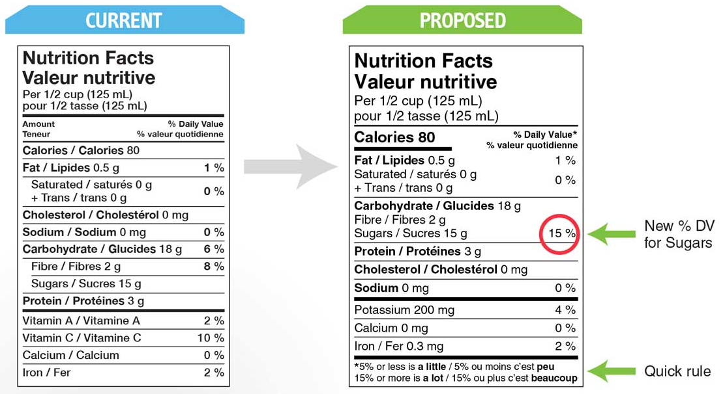

List of Ingredients

All sugars-based ingredients added directly to a food would be required to be grouped in brackets after the common name ‘sugars’ and be ordered in the ingredient list based on their total relative contribution to the food. Figure 2 includes an example of the proposed change to the list of ingredients. A draft definition of ‘sugars-based ingredients’ has been proposed (Health Canada 2015c).

Figure 2. Changes proposed for the list of ingredients

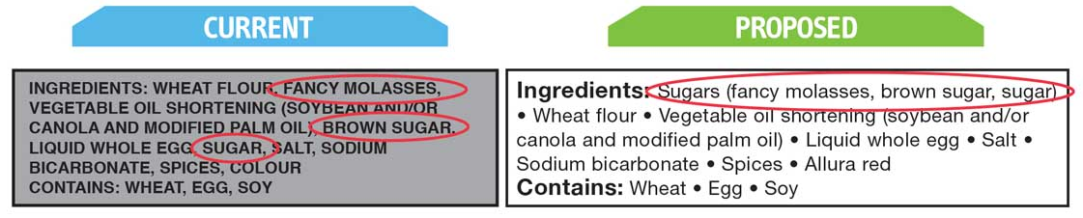

The purpose of this measure is to assist consumers to better estimate the relative contribution of added sugars to the food, and apply Canada’s Food Guide recommendation to limit foods high in sugar. It would also help consumers identify unfamiliar sources of sugars, such as fancy molasses. The approach would not, however, identify indirect additions of sugars to a food through the components (e.g. the ingredients of an ingredient), such as the sugars in chocolate chips to a cookie.

A five year transition period applies if the changes proceed. The draft legislation and a regulatory impact statement were published together in the Canada Gazette in June 2015 and were made available for stakeholder comment until 27 August 2015 (Health Canada 2015b, Health Canada 2015c). The outcome of this latest consultation has not yet been made available.

3.2 United States
The US FDA released a new Nutrition Facts Label for packaged foods in May 2016 in the final rule (regulation) ‘Food Labeling: Revision of the Nutrition and Supplement Facts Label’ (FDA 2016a, 2016b). The new rule requires the amount of ‘added sugars’ in grams and as % DV to be included on the Nutrition Facts Label. The added sugars content shall be indented under ‘Total Sugars’ (changed from ‘Sugars’) using the words ‘Includes X g Added Sugars’. This change is being introduced in conjunction with a number of revisions to the Nutrition Facts Label under the final rule. The final rule becomes effective on 26 July 2016 and manufacturers have two years to comply (26 July 2018), except for manufacturers with less than $10 million in annual food sales which have three years to comply (26 July 2019). An illustration of the changes in the rule is shown in Figure 3.

The rule defines ‘added sugars’ as either added during the processing of foods, or are packaged as such, and include sugars (free, mono- and di-saccharides), sugars from syrups and honey, and sugars from concentrated fruit or vegetable juices that are in excess of what would be expected from the same volume of 100 percent fruit or vegetable juice of the same type, except that fruit or vegetable juice concentrated from 100 percent juices sold to consumers, fruit or vegetable juice concentrates used towards the total juice percentage label declaration under § 101.30 or for Brix standardization under § 102.33(g)(2) of this chapter, fruit juice concentrates which are used to formulate the fruit component of jellies, jams, or preserves in accordance with the standard of identities set forth in §§ 150.140 and 150.160 of this chapter, or the fruit component of fruit spreads shall not be labeled as added sugars.

Figure 3. Rule changes for the US Nutrition Facts Label

Original Label New Label
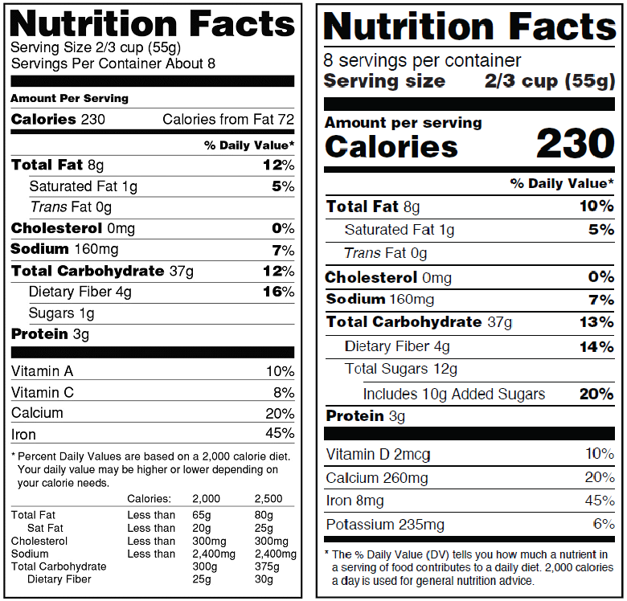
The US FDA has stated that the nutrition information on the label has been updated to assist consumers in maintaining healthy dietary practices. The evidence used to support the decision to require the added sugars declaration included the scientific evidence underlying the 2010 and the 2015-2020 Dietary Guidelines for Americans. In particular, the recommendation to reduce the caloric intake from added sugars. The FDA also noted that expert groups (e.g. the American Heart Association, the American Academy of Pediatrics, the Institute of Medicine and the WHO) recommend decreasing intake of added sugars. The FDA has commented that if added sugars are consumed in excess, it becomes more difficult to also eat foods with enough dietary fiber and essential vitamins and minerals and still stay within calorie limits. The added sugars declaration in grams and as % DV are intended to help increase consumer awareness of the quantity of added sugars in foods; and understand the nutrition information in the context of a total daily diet.

The proposed rule on changes to the Nutrition Facts Label was first published in the Federal Register in March 2014 (FDA 2014). The rule originally proposed that the amount of ‘added sugars’ in a serving of a food should be declared (in grams) in the Nutrition Facts label, indented under ‘sugars’. In July 2015, the US FDA issued a supplemental proposed rule that included further revisions to the Nutrition Facts Label (FDA 2015a). Under this supplemental proposed rule, the declaration of the % DV for added sugars was suggested, to be based on a Daily Reference Value (DRV) of 10% of total energy intake from added sugars. Additionally, the supplemental proposed rule suggested a change to the footnote in the Nutrition Facts Label to assist consumer understanding of the % DV concept.

The US FDA received nearly 289,000 comments in total to the proposed and supplemental proposed rules (FDA 2015b). In response to concerns raised in comments that consumers would not understand that added sugars are a subset of total sugars (i.e. some consumers may add these amounts together), the declaration of added sugars was revised in the final rule to require the words ‘Includes X g Added Sugars’ to clarify that added sugars is a subcomponent of total sugars.

FSANZ notes there has been significant media attention in the US in relation to the proposed changes for added sugar labelling (prior to release of the final rule). Critics were cited as questioning whether there is sufficient evidence to require an ‘added sugars’ declaration because there is no difference in how the body metabolises naturally occurring versus added sugars, and the scientific basis for establishing a DRV for added sugars is extremely weak. Some stakeholders believe an ‘added sugar’ declaration will adversely affect consumer understanding of the total sugar content of products. Others noted there is no accurate analytical method to determine added from naturally occurring sugars (important for compositional analysis in the Nutrition Facts Label). Some nutrition scientists also raised concerns that highlighting added sugars on labels may divert attention away from total calories and other important contributors to weight gain.

In contrast, media reported that many public health stakeholders support the proposed labelling changes. These stakeholders agreed that naturally occurring sugars and added sugars have the same physiological impact, but note the difference is significant when considering dietary quality. They believe the additional label information will assist consumers in making dietary decisions that would reduce their consumption of added sugars. Some industry stakeholders also expressed strong support for the proposed changes on the basis that it reflects the dietary guidelines to reduce calorie intake from added sugars. However, some of these industry stakeholders qualified their support by stating that certain ingredients (for example, lactose, and mono and disaccharides from any pure fruit ingredient such as juices, concentrates, fruit pieces, pulps and purees) should not be counted as ‘added sugars’ provided that these ingredients are not added for sweetening purposes.

3.3 United Kingdom
A Private Member’s Bill entitled ‘Sugar in Food and Drinks (Targets, Labelling and Advertising) Bill 2015-16’ (UK Parliament 2015) was presented to Parliament on 21 October 2015. The Bill proposed to require that the sugar content be represented on food labels in ‘teaspoon units’, where one teaspoon equals 4 grams of sugar. The Bill also proposed to prohibit the use of language suggesting that a food is ‘healthy’ or ‘low-fat’ where the sugar content of the food exceeds 20%.

Under the proposed legislation, ‘sugar’ would have the same meaning as in the Food Labelling Regulations 1996 (Food Labelling Regulations 1996). The Food Labelling Regulations does not define ‘sugar’; rather it defines ‘sugars’ to mean sugars, in the context of nutrition labelling, means all monosaccharides and disaccharides present in food, but excludes polyols. This definition aligns with the definition of ‘sugars’ in the EU regulations (European Parliament 2011).

The Bill proposed two other measures in addition to the labelling requirement. These would require the government to set targets for sugar content in food and drinks and consider standards on the information provided in advertising. The Bill would require the government to publish and promote the WHO’s current guideline on sugars intake and to translate the recommended daily amounts in grams into teaspoon units at the rate of 4 grams per teaspoon. FSANZ notes that a contemporary official report published by Public Health England sets out daily maximum sugar intakes in teaspoon amounts for different age groups (Public Health England 2015).

The media has reported some stakeholders concerns that the Bill’s provisions could breach existing EU food legislation, specifically Regulation (EC) No 1924/2006 on nutrition and health claims. Article 4 of the Regulation covers nutrient profiling with respect to how much fat, sugar and salt should be allowed in a food for it to be considered healthy or not, although to date, nutrient profiling has not be implemented into EU legislation. The draft Bill was considered to contravene the provisions in the Regulation, as the 20% sugar content restriction was viewed as a de facto national measure resulting in a ‘nutrient profiling’ of foods. FSANZ notes that on 12 April 2016, Members of the European Parliament voted to scrap nutrient profiles as a condition for nutrition and health claims, so the contravention issue may no longer be relevant.

The second reading of the Bill (step 2) was due to occur in the House of Commons on 20 November 2015, but was postponed, and the Bill appears to have halted. According to the UK Parliament website (UK Parliament 2015) the 2015-16 session of Parliament has ended and this Bill will make no further progress.

4 References
Blewett N, Goddard N, Pettigrew S, Reynolds C, Yeatman H (2011) Labelling logic: Review of food labelling law and policy (2011). Department of Health and Ageing, Canberra, Australia. http://www.foodlabellingreview.gov.au/internet/foodlabelling/publishing.nsf/content/48C0548D80E715BCCA257825001E5DC0/$File/Labelling%20Logic_2011.pdf Accessed 8 March 2016

Code of Federal Regulations (2016) CFR 21.101.4 – Food; designation of ingredients http://www.ecfr.gov/cgi-bin/text-idx?SID=57331c73d201d4f697a3900d82b38e70&mc=true&node=pt21.2.101&rgn=div5
Accessed 7 March 2016

Codex Alimentarius (2010) General Standard for the Labelling of Prepackaged foods CODEX STAN 1-1985 http://www.fao.org/fao-who-codexalimentarius/standards/list-standards/en/ Accessed 7 March 2016

European Parliament (2011) Regulation (EU) No 1169/2011 of the European Parliament and of the Council of 25 October 2011 on the provision of food information to consumers http://eur-lex.europa.eu/legal-content/EN/TXT/?qid=1460948531511&uri=CELEX:32011R1169 Accessed 8 March 2016

FDA (2014) Food Labeling: Revision of the Nutrition and Supplement Facts Labels. US Food and Drug Administration. Federal Register 79 FR 11879 p 11879 -11987 https://www.federalregister.gov/articles/2014/03/03/2014-04387/food-labeling-revision-of-the-nutrition-and-supplement-facts-labels Accessed 19 April 2016

FDA (2015a) Food Labeling: Revision of the Nutrition and Supplement Facts Labels; Supplemental Proposed Rule to Solicit Comment on Limited Additional Provisions. US Food and Drug Administration. Federal Register 80 FR 44303 p 44303 - 44312 https://www.federalregister.gov/articles/2015/07/27/2015-17928/food-labeling-revision-of-the-nutrition-and-supplement-facts-labels-supplemental-proposed-rule-to Accessed 19 April 2016

FDA (2015b) Food Labeling: Revision of the Nutrition and Supplements Facts Label. US Food and Drug Administration. Docket Folder. Docket ID: FDA-2012-N-1210 http://www.regulations.gov/#!docketDetail;D=FDA-2012-N-1210 Accessed 19 April 2016

FDA (2016a) Changes to the Nutrition Facts Label http://www.fda.gov/Food/GuidanceRegulation/GuidanceDocumentsRegulatoryInformation/LabelingNutrition/ucm385663.htm#images Accessed 23 May 2016

FDA (2016b) Food Labeling: Revision of the Nutrition and Supplements Facts Label. US Food and Drug Administration. Federal Register, Public Inspection: Rule https://federalregister.gov/a/2016-11867 Accessed 27 May 2016

Food and Drug Regulations (2016) C.R.C., c. 870, Part B, Division 1. Canada http://laws-lois.justice.gc.ca/eng/regulations/c.r.c.,_c._870/index.html Accessed 7 March 2016

Food Labelling Regulations (1996) No. 1499. United Kingdom http://www.legislation.gov.uk/uksi/1996/1499/contents/made Accessed 2 May 2016

Health Canada (2014) Health Canada’s proposed changes to the core nutrients declared in the Canadian Nutrition Facts table. Archived June 2015. http://www.hc-sc.gc.ca/fn-an/consult/2014-core-nutrients-principaux-nutriments/document-consultation-eng.php#c. Accessed 5 April 2016

Health Canada (2015a) Consulting Canadians to modernize and improve food labels. What we heard http://www.hc-sc.gc.ca/fn-an/label-etiquet/modernize-report-moderniser-rapport-eng.php#s1 Accessed 5 April 2016

Health Canada (2015b) Canada Gazette, Part I consultation on proposed food label changes. http://healthycanadians.gc.ca/health-system-systeme-sante/consultations/food-label-etiquette-des-aliments/process-processus-eng.php Accessed 6 April 2016

Health Canada (2015c). Regulations Amending the Food and Drug Regulations — Nutrition Labelling, Other Labelling Provisions and Food Colours. Canada Gazette Vol 149 http://www.gazette.gc.ca/rp-pr/p1/2015/2015-06-13/html/reg1-eng.php Accessed 6 April 2016

Public Health England (2015) Sugar Reduction. The evidence for action. United Kingdom. https://www.gov.uk/government/publications/sugar-reduction-from-evidence-into-action Accessed 2 May 2016

UK Parliament (2015) Sugar in Food and Drinks (Targets, Labelling and Advertising) Bill 2015-16 http://services.parliament.uk/bills/2015-16/sugarinfoodanddrinkstargetslabellingandadvertising.html Accessed 2 May 2016

Appendix 1: Summary of international ingredient labelling requirements reviewed
Codex | European Union | United States | Canada
Ingredients shall be listed in descending order of ingoing weight.  A specific name shall be used – the name shall indicate the true nature of the food and normally be specific and not generic.  The following class names may be used:  Fats/oils  - refined oils (other than olive), the name ‘oil’ together with the term ‘vegetable’ or ‘animal’,  - refined fat, the name ‘fat’ together with the term ‘vegetable’ or ‘animal’  Sugar  - all types of sucrose, the name ‘sugar’ | Ingredients shall be declared in descending order of weight.  A specific name shall be used, where applicable.  Fats/oils  - refined oils/fats of vegetable origin may be grouped together under the designation ‘vegetable oils/fats’ followed by a list of specific vegetable origin and may be followed by the phrase ‘in varying proportions’.  - if grouped together shall be listed in the ingredient list on the basis of the total weight of the vegetable oils/fats present.  The category name may be used rather than a specific name for refined oils and fats of animal origin - the name ‘oil’ or ‘fat’ with the term ‘animal’ or the specific animal origin.  Sugar  The following category names may be used:  - all types of sucrose, the name ‘sugar’  Specific provisions concerning the indication of ingredients by descending order of weight  Ingredients constituting less than 2 % of the finished product may be listed in a different order after the other ingredients.  Ingredients, which are similar or mutually substitutable, likely to be used in the manufacture or preparation of a food without altering its composition, its nature or its perceived value, and in so far as they constitute less than 2 % of the finished product. May be referred to in the list of ingredients by means of the statement ‘contains … and/or …’ where at least one of no more than two ingredients is present in the finished product. | Ingredients shall be listed in descending order by weight (with variation allowed for ingredients present in 2% or less by weight).  A specific name shall be used and not a collective (generic) name.  Fats/Oils  - each individual fat/oil to be declared by its specific common or usual name (e.g. ‘cottonseed oil’, ‘beef fat’) in its order of predominance in the food, except that  - fats and oils do not have to be grouped, but blends of fats or oils may be listed in their order of predominance as ‘ x shortening’ or ‘blend of x oils/fats’ the x to be ‘vegetable’, ‘animal’, ‘marine’ with or without the terms ‘fats’ or ‘oils’, or combination of these if, each individual fat or oil is given in brackets following the term (e.g. ‘vegetable oil shortening (soybean and cottonseed oil)’)  - for products that are blends of fats and/or oils and for foods in which fats/oils are the predominant ingredient (i.e. the combined weight equals or exceeds the weight of the most predominant ingredient that is not a fat or oil), the listing of the names in brackets shall be in descending order of predominance  - In all foods in which a blend is used, the listing in brackets need not be in descending order if because of varying mixtures used, the manufacturer is unable to adhere to a constant pattern of fats/oils in the product  - fat/oil ingredients not present in a product may be listed if they may sometimes be used. They shall be identified by words indicating they may not be present (e.g. ‘or’, ‘and/or’, ‘contains one or more of the following’).  - No fat/oil shall be listed unless actually present if they constitute the predominant ingredient.  Sugar  - For the purposes of ingredient labelling ‘sugar’ shall refer to sucrose, which is obtained from sugar cane or sugar beets. | Ingredients must be declared in descending order by weight. Certain ingredients (e.g. spices, flavours) can be listed at the end in any order.  Ingredients must be declared by their common name.  Fats/Oils  Mandatory common names include:  - any oil, fat or tallow except lard, leaf lard or suet, the name of the meat from which it is obtained plus ‘oil’, ‘fat’, or ‘tallow’.  - coconut oil, palm oil, palm kernel oil, peanut oil or cocoa butter that has been hydrogenated or partially hydrogenated/ or that has been modified by the complete or partial removal of a fatty acid, the term ‘hydrogenated’/ ‘modified’ plus the specific name of the oil or fat.  Permitted class/collective name includes:  - vegetable fats or oils, except coconut oil, palm oil, palm kernel oil, peanut oil or cocoa butter, the collective name ‘vegetable oil’ or ‘vegetable fat’.  Sugar  Permitted class/collective names:  - sugar, liquid sugar, invert sugar or liquid invert sugar, singly or in combination, the collective name ‘sugar’  - Sugar or glucose-fructose, singly or in combination the collective name ‘sugar/glucose-fructose’  Variation in ingredients  When ingredients are omitted or substituted in a 12 month period:  - All of the ingredients that may be used throughout the 12 months must be listed  - it must be clearly stated that the ingredient may not be present or may be substituted  - the ingredients that may be omitted or substituted may be grouped in the same class of foods that are normally used and within the group, and the foods within the group must be listed in descending order of proportion in which they will probably be used during the 12 months.  When proportions of ingredients are varied the ingredient list may show the same proportions throughout the 12 month period if:  - it is clearly stated that the proportions indicated are subject to change  - the ingredients are listed in descending order of the proportion in which they will be in for the majority of the 12 month period.  - For example: ‘Sugar and/or dextrose’ means that the amounts of sugar and/or dextrose will be varying over a 12 month period and a product may contain only sugar, only dextrose, or a mixture of both. As sugar is listed first, it is expected that over the 12 month calendar year, sugar is present in higher quantities.

The % DV is based on a Daily Reference Value (DRV) for added sugars. A DRV of 50 g for adults and children 4 or more years of age has been established by the US FDA
Note that references to other sections of the chapter are contained in the Code of Federal Regulations (CFR), Title 21 – Food and Drugs, Chapter I: http://www.accessdata.fda.gov/scripts/cdrh/cfdocs/cfcfr/cfrsearch.cfm .
Labelling of Prepackaged Foods (CODEX STAN 1-1985)
Regulation (EU) No 1169/2011 of the European Parliament and of the Council of 25 October 2011 on the provision of food information to consumers
21CFR 101.4 – Food; designation of ingredients
Food and Drug Regulations (C.R.C., c.870), Part B, Division 1, General

